Dbase protect_spam

DBMS ASSIGNMENT-1

P. Sai Charan

1602-21-737-045

IT-A

**Abstract:**

The Database Protect-Spam project is a sophisticated database system designed to protect users from spam by providing relevant suggestions based on their input. The system consists of five tables, including User, Category, Input, Keyword and Suggestion which capture and analyse user input data and provide appropriate feedback. Machine learning algorithms help identify patterns and relationships between different user inputs, enabling highly accurate and relevant suggestions. Users can provide feedback on the suggestions provided, further refining and improving the system's performance over time. Overall, the Database Protect-Spam system provides a powerful and user-friendly approach to spam protection, making it an essential tool for anyone looking to stay safe and secure online.

**Requirements:**

Tables that I have identified are: User, Category, Input, Keyword and Suggestion

**1.Users_details Table:**

|  |  |  |
| --- | --- | --- |
| Attribute | Domain | CONSTARINT |
| Email | VARCHAR | Primary_Key |
| Username | VARCHAR | Not Null |
| Password | VARCHAR | Not Null |
| DOB | DATE | Not Null |
| Phone Number | VARCHAR | Not Null |

**2.Login Table:**

|  |  |  |
| --- | --- | --- |
| Attribute | Domain | CONSTRAINT |
| Username | VARCHAR | Foreign key |
| Password | VARCHAR | Foreign key |

|  |  |  |
| --- | --- | --- |
| Attribute | Domain | Constraint |
| Id | VARCHAR | Primary_Key |
| To | VARCHAR | Not Null |
| From | VARCHAR | Not Null |
| Type | VARCHAR | Not Null |
|  |  |  |

**3.Inbox Table:**

**4.Spam Table:**

|  |  |  |
| --- | --- | --- |
| Attribute | Domain | CONSTRAINT |
| Resolve id | VARCHAR | Primary_Key |
| Type of spam | VARCHAR | Not Null |
| Spam msg | VARCHAR | Not Null |

**5.Resolve Table**

|  |  |  |
| --- | --- | --- |
| Attribute | Domain | CONSTRAINT |
| Resolve id | VARCHAR | Foreign_Key |
| Description | VARCHAR | Not Null |

**ER Diagram:**

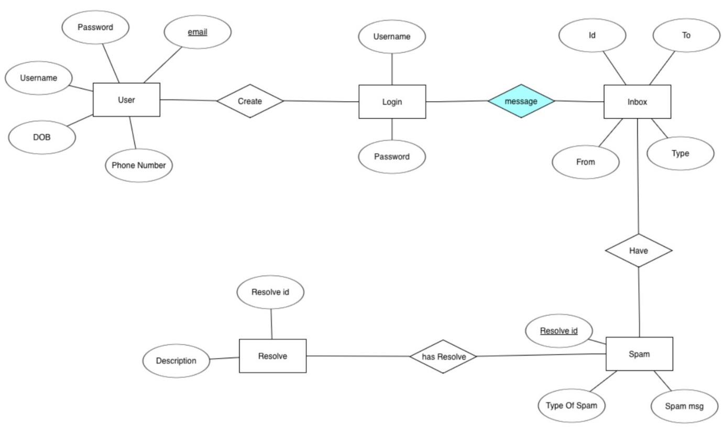

**DDL COMMANDS:**

1.Creating table for User_details with constraints :

**QUERY**: create table user_details(username varchar(20),

2 email varchar(20),

3 phonenumber varchar(20),

4 password varchar(20),

5 dob date,

6 primary key(email));

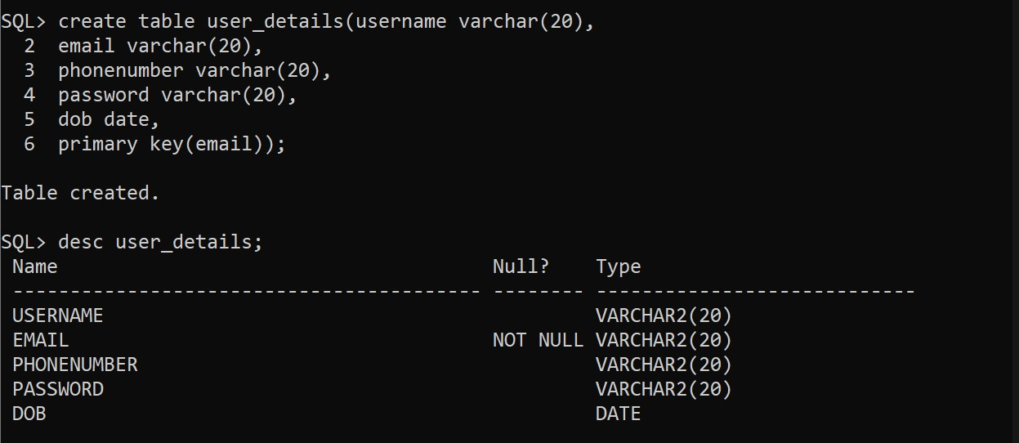

2. Creating Login table:

**QUERY**: create table login_details(username varchar(20),

2 password varchar(20));

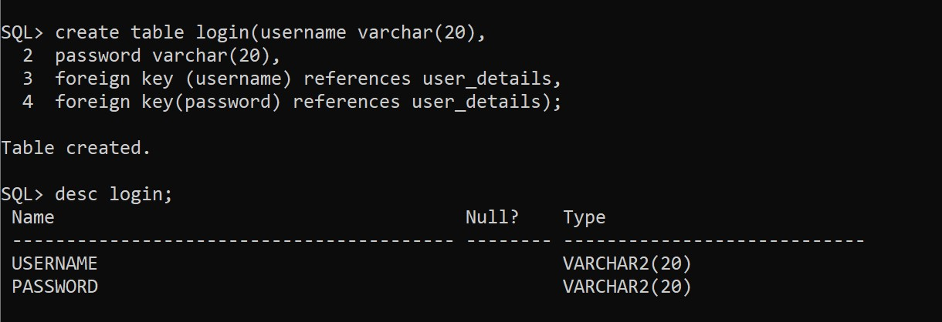

3.Creating Inbox table:

**QUERY:** create table inbox(t_o varchar(20),

2 from_ varchar(20),

3 id varchar(20),

4 type varchar(20),

5 primary key(id));

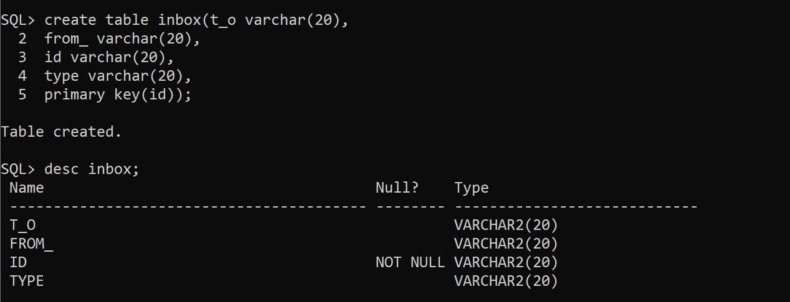

4.Creating Spam table:

**QUERY**: create table spam(resolve_id varchar(20),

2 type_of_spam varchar(20),

3 spam_msg varchar(20),

4 primary key(resolve_id));

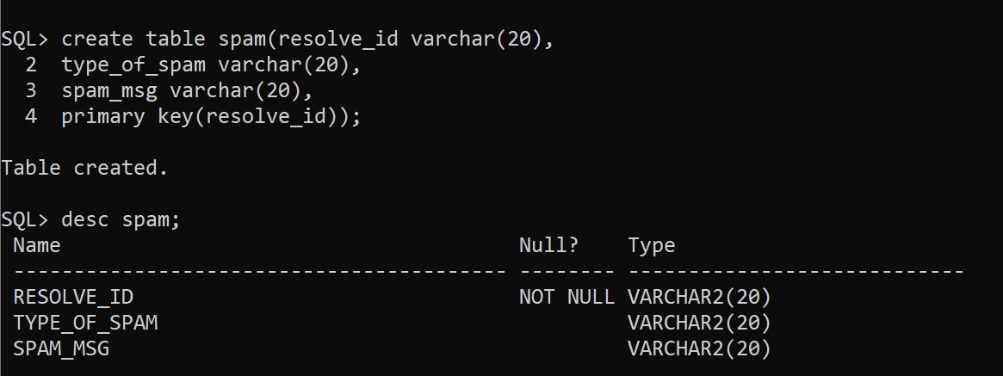

5.Creating Resolve table:

**QUERY :** create table resolve(resolve_id varchar(20),

2 description varchar(20));

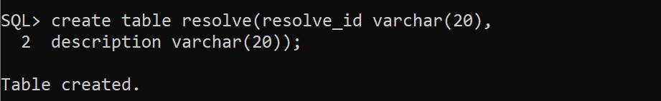

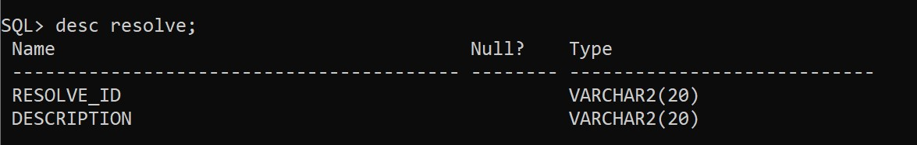

**DML COMMANDS:**

1.Insert values into Users:

**QUERY:** insert into user_details values('&username','&email','&phonenumber','&password','&dob')

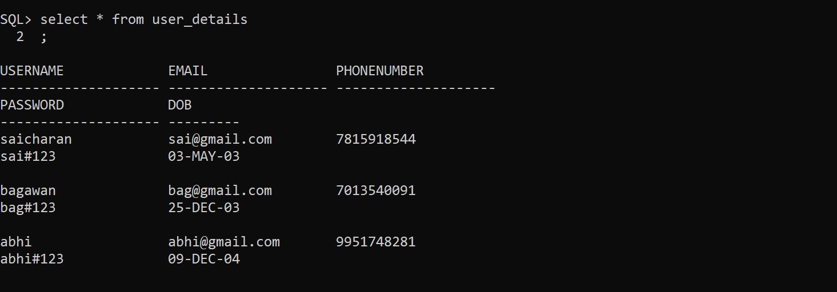

2.Insert values into Login:

**QUERY:** insert into values('&username','&password');

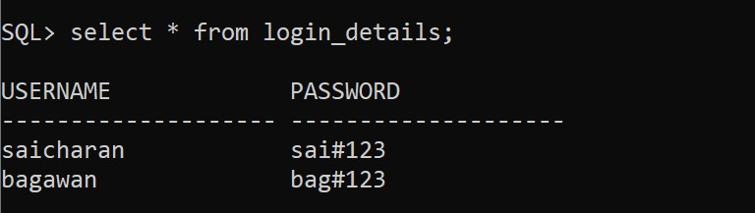

3.Insert values into Inbox:

**QUERY**: insert into inbox values('&t_o','&from_','&id','&type');

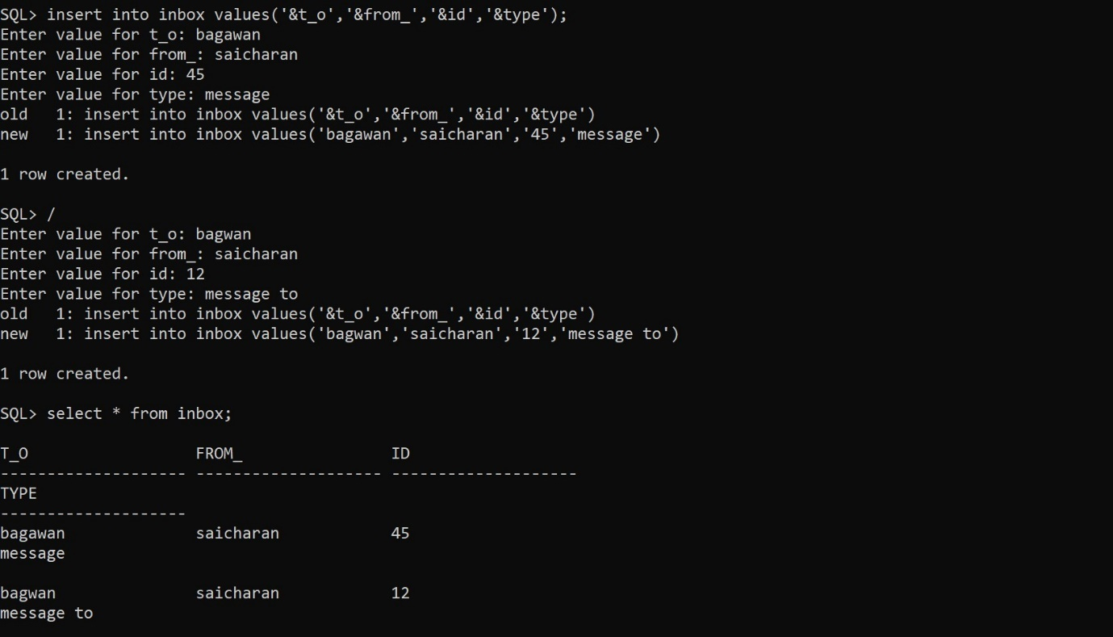

4.Insert values into Spam:

**QUERY:** insert into Keyword values(&keyword;&input_id,'&keyword_text');

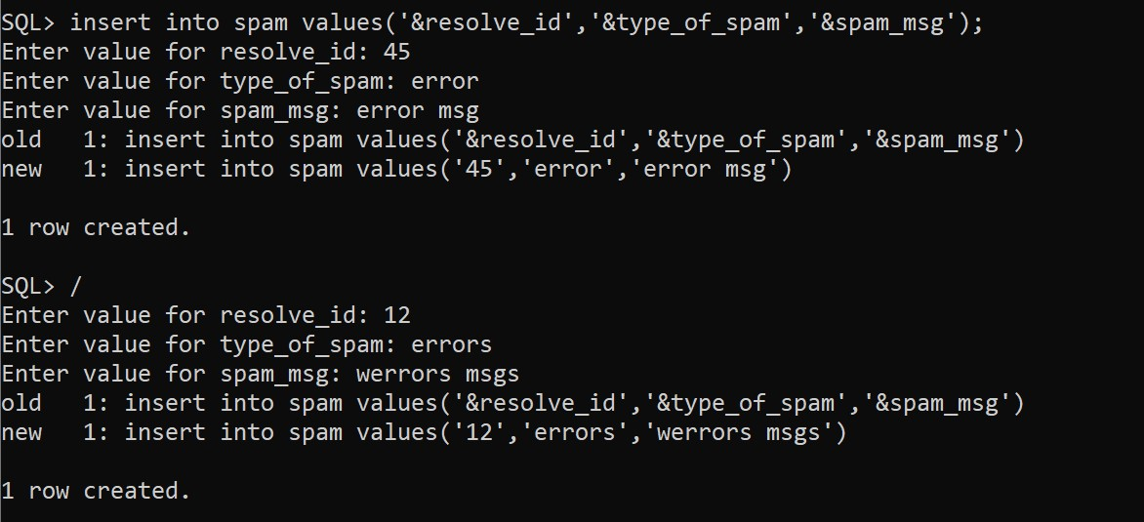

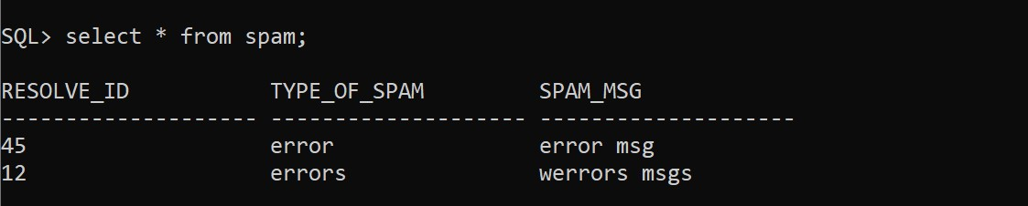

5.Insert values into Resolve:

**QUERY:** insert into resolve values('&resolve_id','&description');

